Table Cell Style Guide

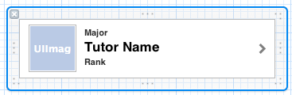

Helvetica Bold 11.0

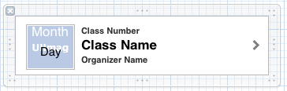  
  
  
  
  
  
Study Cell

Helvetica Bold 17.0

Helvetica Bold 11.0

Helvetica Bold 11.0

Helvetica Bold 17.0

Helvetica Bold 11.0